Trabalho Teórico 7



Slide G.

1)Em nosso exemplo, o algoritmo terminou sua execução?

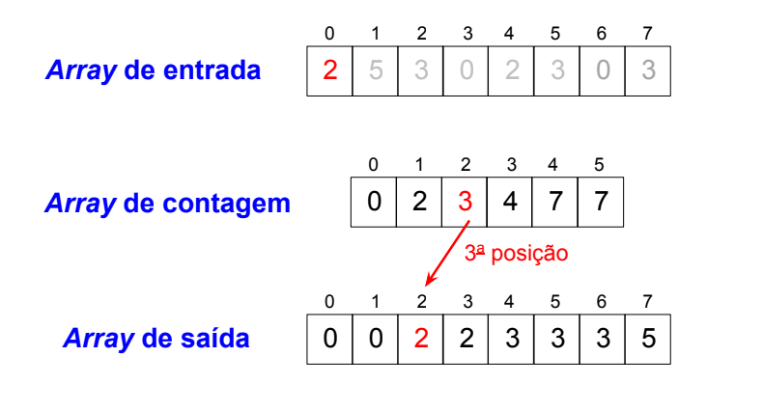

Não, pois é necessário atualizar os elementos do array de contagem

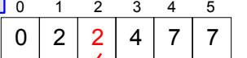

2)Seja o array de entrada abaixo, quais serão os valores contidos no array de contagem antes e depois de copiarmos os elementos da entrada para a saída?

Array Original🡪

|  |  |  |  |  |  |  |  |  |  |  |  |  |  |  |  |  |  |
| --- | --- | --- | --- | --- | --- | --- | --- | --- | --- | --- | --- | --- | --- | --- | --- | --- | --- |
| 12 | 4 | 8 | 2 | 14 | 17 | 6 | 18 | 10 | 16 | 5 | 15 | 13 | 9 | 1 | 11 | 7 | 3 |

Array Meio🡪

|  |  |  |  |  |  |  |  |  |  |  |  |  |  |  |  |  |  |  |
| --- | --- | --- | --- | --- | --- | --- | --- | --- | --- | --- | --- | --- | --- | --- | --- | --- | --- | --- |
| 0 | 1 | 1 | 1 | 1 | 1 | 1 | 1 | 1 | 1 | 1 | 1 | 1 | 1 | 1 | 1 | 1 | 1 | 1 |

Array Meio🡪

|  |  |  |  |  |  |  |  |  |  |  |  |  |  |  |  |  |  |  |
| --- | --- | --- | --- | --- | --- | --- | --- | --- | --- | --- | --- | --- | --- | --- | --- | --- | --- | --- |
| 0 | 1 | 2 | 3 | 4 | 5 | 6 | 7 | 8 | 9 | 10 | 11 | 12 | 13 | 14 | 15 | 16 | 17 | 18 |

3) O Counting Sort pode ser aplicado adequadamente na ordenação de strings e números reais?

Resp: Não, no caso dos números reais temos infinitos números no intervalo 0 – 1 e como ele é indicado para manipulação de Inteiros não funcionaria em Reais. Porém é possível usar em uma string usando os valores da tabela Ascii como referência mas não seria funcional.

4) Nosso dinheiro é um número real. Conseguimos utilizar adequadamente o Counting Sort para ordenar valores financeiros?

Resp: Sim, pois apesar de Dinheiro estar dentro dos conjuntos reais sabemos que os centavos são finitos de até 100 unidades então basta multiplicar por 100 os valores, logo o 00,01 ocuparia a 1 posição, 00,10 a 10 posição 1,00 a 100 posição:

1)Mostre todas as comparações e movimentações do algoritmo anterior para o array abaixo:

|  |  |  |  |  |  |  |  |  |  |  |  |  |  |  |  |  |  |
| --- | --- | --- | --- | --- | --- | --- | --- | --- | --- | --- | --- | --- | --- | --- | --- | --- | --- |
| 12 | 4 | 8 | 2 | 14 | 17 | 6 | 18 | 10 | 16 | 5 | 15 | 13 | 9 | 1 | 11 | 7 | 3 |

Passos Básicos

Before Shell Sort

Vector {12,4,8,2,14,17,6,18,10,16,15,5,13,9,1,11,7,3}

Number case

Vector {0,1,1,1,1,1,1,1,1,1,1,1,1,1,1,1,1,1,1}

After Shell Sort

Vector {1,2,3,4,5,6,7,8,9,10,11,12,13,14,15,16,17,18}

Todos os passos

Before Shell Sort

Vector {12,4,8,2,14,17,6,18,10,16,15,5,13,9,1,11,7,3}

Number -->Vector {0,1,1,1,1,1,1,1,1,1,1,1,1,1,1,1,1,1,1}

Ordenado-->Vector {0,0,0,0,0,0,0,0,0,0,0,0,0,0,0,0,0,0}

Ordenado-->Vector {1,0,0,0,0,0,0,0,0,0,0,0,0,0,0,0,0,0}

Ordenado-->Vector {1,2,0,0,0,0,0,0,0,0,0,0,0,0,0,0,0,0}

Ordenado-->Vector {1,2,3,0,0,0,0,0,0,0,0,0,0,0,0,0,0,0}

Ordenado-->Vector {1,2,3,4,0,0,0,0,0,0,0,0,0,0,0,0,0,0}

Ordenado-->Vector {1,2,3,4,5,0,0,0,0,0,0,0,0,0,0,0,0,0}

Ordenado-->Vector {1,2,3,4,5,6,0,0,0,0,0,0,0,0,0,0,0,0}

Ordenado-->Vector {1,2,3,4,5,6,7,0,0,0,0,0,0,0,0,0,0,0}

Ordenado-->Vector {1,2,3,4,5,6,7,8,0,0,0,0,0,0,0,0,0,0}

Ordenado-->Vector {1,2,3,4,5,6,7,8,9,0,0,0,0,0,0,0,0,0}

Ordenado-->Vector {1,2,3,4,5,6,7,8,9,10,0,0,0,0,0,0,0,0}

Ordenado-->Vector {1,2,3,4,5,6,7,8,9,10,11,0,0,0,0,0,0,0}

Ordenado-->Vector {1,2,3,4,5,6,7,8,9,10,11,12,0,0,0,0,0,0} *

Ordenado-->Vector {1,2,3,4,5,6,7,8,9,10,11,12,13,0,0,0,0,0}

Ordenado-->Vector {1,2,3,4,5,6,7,8,9,10,11,12,13,14,0,0,0,0}

Ordenado-->Vector {1,2,3,4,5,6,7,8,9,10,11,12,13,14,15,0,0,0}

Ordenado-->Vector {1,2,3,4,5,6,7,8,9,10,11,12,13,14,15,16,0,0}

Ordenado-->Vector {1,2,3,4,5,6,7,8,9,10,11,12,13,14,15,16,17,0}

Ordenado-->Vector {1,2,3,4,5,6,7,8,9,10,11,12,13,14,15,16,17,18}

After Shell Sort

Vector {1,2,3,4,5,6,7,8,9,10,11,12,13,14,15,16,17,18}